
SET -3
Sreenidhi Institute of Science and Technology
Regulations:
A15
(An Autonomous Institution)
Code No: 5H315 Date:1-Dec-16(FN)
B. TECH. II-Year I-Semester Examinations, Nov/Dec 2016 (Regular)
ENGINEERING MATHEMATICS-III (ECE )

Time: 3 Hours Max. Marks:75
Note: a) No additional answer sheets will be provided.
b) All sub-parts of a question must be answered at one place only, otherwise it will not be valued.
c) Assume any missing data.

Part - A
Max.Marks:25

Answer all QUESTIONS
1. Determine 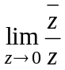, if it exists . [3M]
2. Perform first three approximations of bisection method to find a root of 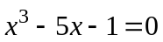. [3M]

3. Prove the relation 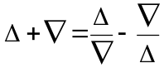, where and 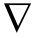 are forward and backward
difference operators respectively. [3M]

4. Find an approximate value of 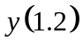 for the differential equation 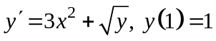
by Euler’s method. [3M]

5. Prove that 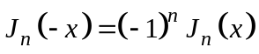, where is an integer. [3M]

6. If 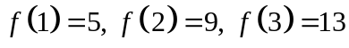 and 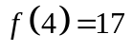, find 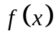. [2M]
7. Find the invariant points of the transformation 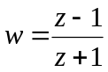. [2M]
8. Evaluate 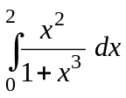 using Simpson’s rule with 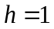. [2M]
9. Compute 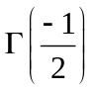. [2M]
10. State Cauchy-Riemann equations in polar form. [2M]

Part – B
Max.Marks:50
ANSWER ANY FIVE QUESTIONS. EACH QUESTION CARRIES 10 MARKS.
1.a) Find the constants 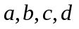such that the function 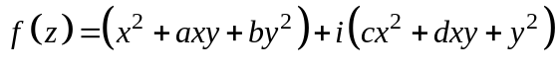
is analytic and express 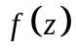in terms of .
b) State Cauchy’s residue theorem and hence evaluate 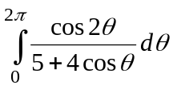.
2.a) Find the image of the closed disk 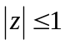 under the transformation 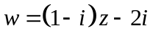 and
sketch the regions.
b) Obtain the bilinear transformation which maps the points 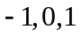 in the plane onto
the points 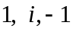 in -plane respectively.

3. a) Evaluate 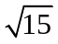 using the equation 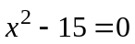 by the fixed point iteration method.
b) Solve the initial value problem 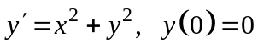 using Picard’s method of
successive approximation in 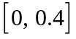 with 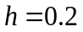.
4.a) Evaluate 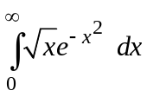 using Gamma function.
b) State Cauchy’s integral formula and hence evaluate 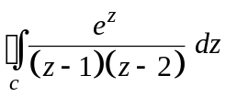, where is
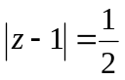.
5 a) Find the smallest positive root of the equation 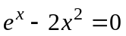 correct to three decimal
places by Newton-Raphson method.
b) Apply Trapezoidal rule to find an approximate value of 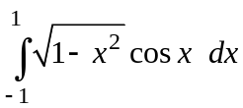 with 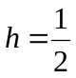.
6.a) Using Gauss forward interpolation formula to find 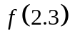 from the following data:
x: | 1 | 2 | 3 | 4 | 5
f(x): | 15.30 | 15.10 | 15.00 | 14.50 | 14.00

b) Find the Lagrange interpolating polynomial from the following data:

x: | -2 | 0 | 1 | 2
f(x): | 3 | 1 | -3 | -1
Hence find the approximate value of 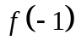.
7. a) Find the approximate value of 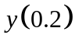 for 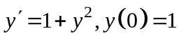 using Taylor series method.
b) Use Runge-Kutta method of order 4 to find for 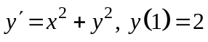.

8.a) Prove that 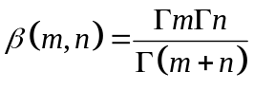.
b) Express 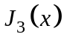 in terms of 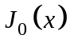 and 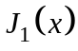.

-- 00 -- 00 --

